Order Of Service

Opening Hymn: TLH 152

Reading: Lent III

The History of the Passion of our Lord

Sermon Hymn: TLH 153

Sermon Text: Luke 12:22-31

First Things First

Confession of Sins: O almighty God, merciful Father, I, a poor miserable sinner, confess unto Thee all my sins and iniquities, with which I have ever offended Thee and justly deserved Thy temporal and eternal punishment. But I am heartily sorry for them and sincerely repent of them, and I pray Thee of Thy boundless mercy and for the sake of the holy, innocent, bitter sufferings and death of Thy beloved Son, Jesus Christ, to be gracious and merciful to me, a poor, sinful being.

Holy Communion

The Lord's Prayer

The Blessing

Closing Hymn: TLH 156

* * * * * * * * * * * * *

Bible Study: Lambs: Cockatiel
Sheep: Philippians

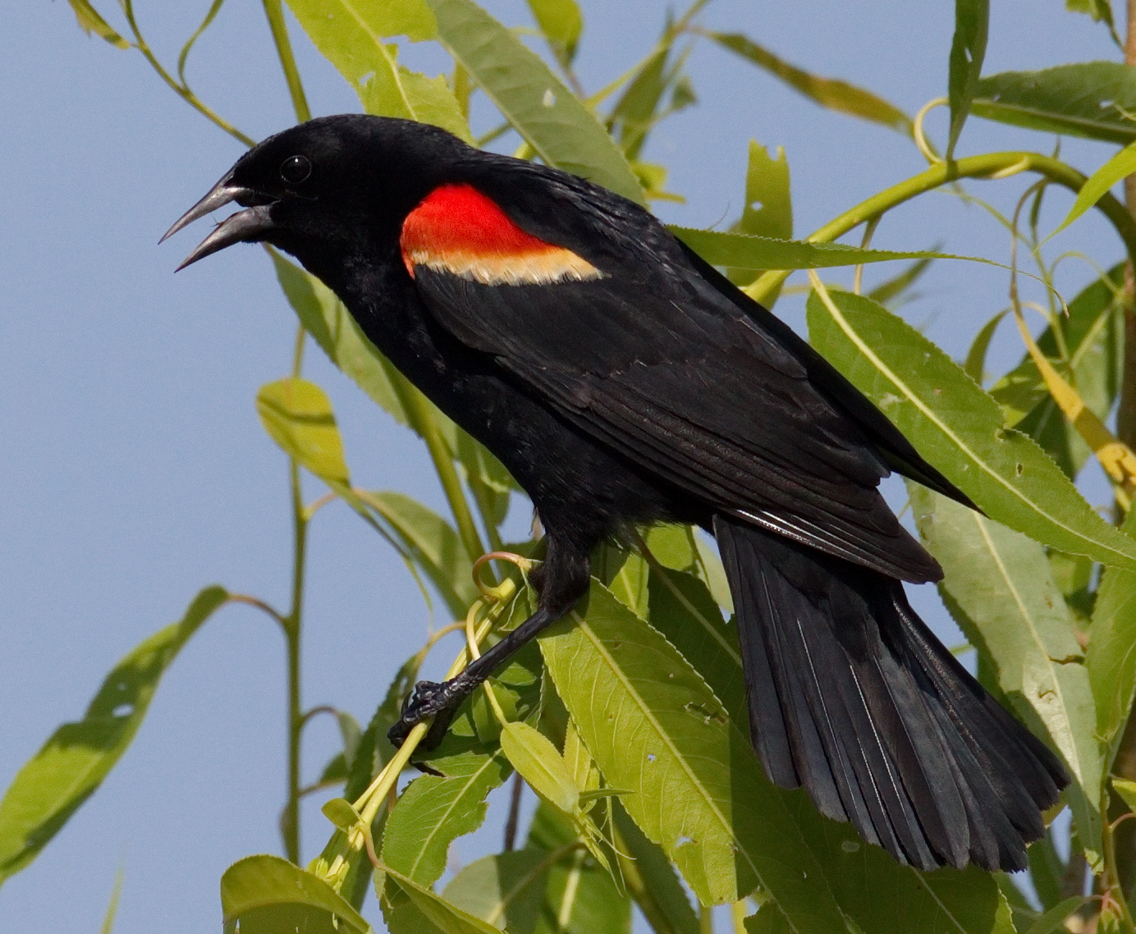

Sound Of Spring

Water
Of
Life

27 Consider the lilies how they grow: they toil not, they spin not; and yet I say unto you, that Solomon in all his glory was not arrayed like one of these.
28 If then God so clothe the grass, which is to day in the field, and to morrow is cast into the oven; how much more will he clothe you, O ye of little faith?
29 And seek not ye what ye shall eat, or what ye shall drink, neither be ye of doubtful mind.
30 For all these things do the nations of the world seek after: and your Father knoweth that ye have need of these things.
31 But rather seek ye the kingdom of God; and all these things shall be added u

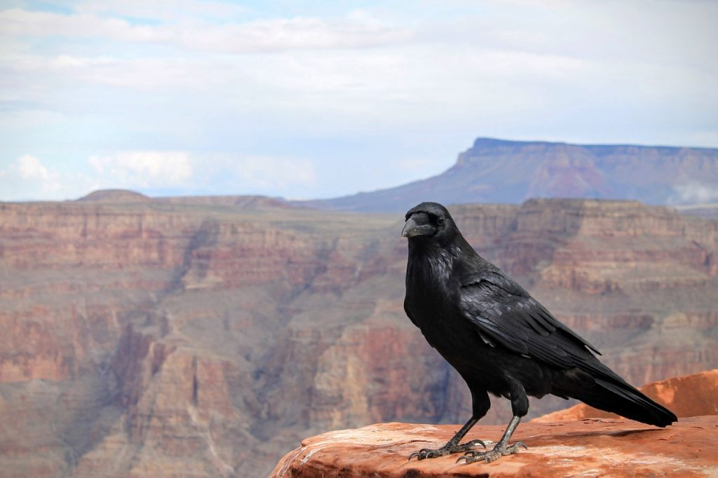

13 March 2022

W A T E R O F L I F E

Independent Christian Church—Conservative Lutheran Doctrine

Worship Service: 9:30 a.m. Bible Study: 10:45 a.m.

Larry Cooper, Pastor E-Mail address:
111 N. Ridge Road lcooper@wateroflife.cc
Coon Valley, WI 54623 Web Site:
www.wateroflife.cc

* * * * * * * * * * * * * * * * * * * * * * * * * * *

Sermon Text: Luke 12:22-32

First Thing First

* * * * * * * * * * * * * * * * * * * * * * * * * * *

22 And he said unto his disciples, Therefore I say unto you, Take no thought for your life, what ye shall eat; neither for the body, what ye shall put on.
23 The life is more than meat, and the body is more than raiment.
24 Consider the ravens: for they neither sow nor reap; which neither have storehouse nor barn; and God feedeth them: how much more are ye better than the fowls?
25 And which of you with taking thought can add to his stature one cubit?
26 If ye then be not able to do that thing which is least, why take ye thought for the rest?

